|  |
| --- |
| **ROULETTE CIRCUIT** |
|  |
| ***DE Lab Project Report*** |
| ***Submitted By*** |
| **GAURAV AGRAWAL ( 18BCS4019 )**  **HIMANSHU VATS ( 18BCS4001 )**  **VANSHAJ TYAGI ( 18BCS4024 )** |
| ***Under the Guidance of*** |
| **Mr. Anshul Sharma**  **Mr. Divneet Singh Kapoor**  **Mr. Khushal Thakur** |
| **Assistant Professors, Academic Unit – 1** |
|  |
| **Academic Unit-1**  **Chandigarh University** |

**Table of Contents**

1. Problem Identification .......................................................................................................... 1

2. Features................................................................................................................................. 2

3. Design Flow ......................................................................................................................... 3

4. Outcome ............................................................................................................................... 4

5. Cost Analysis ........................................................................................................................ 6

7. Product Catalogue ................................................................................................................ 7

**1. Problem Identification**

*Statement of the problem which is meant to be solved by the presented project.*

In this we have a problem in which we have to find the solution for the biased dice or for the defected dice where there are two numbers are same there this type of circuit with name Leds with no’s can helps us .

Basically the roulette wheel consists of certain numbers arranged circularly and each person who plays the game has to bet a certain amount against any number he/she chooses. One person need to touch a pair of touch contacts provided at the left side of circuit. Then the LED's rotate for some time and come to halt at a random number. The persons who bet money on the number at which the LED stops will get all the amount that has been bet by everyone who played that particular game. The betting can be done by the help of numbers on it or the color of LED .

**2. Features**

*Capabilities and limitations of the project.*

CAPABILITIES:

1. It can be used as a betting wheel where people randomly choose a number or color of LED and win money.
2. It can be used as dice in small board game making with 6 LEDs.
3. It can be used as to show the pattern of LEDs.

LIMITATION:

1. At a time you can only use 10 LEDs only.

**3. Design Flow**

# Block Diagram

(*Functional diagram depicting the flow of information in your system. Do not define exact components, only use generic terms. Must include modifications as well.)*

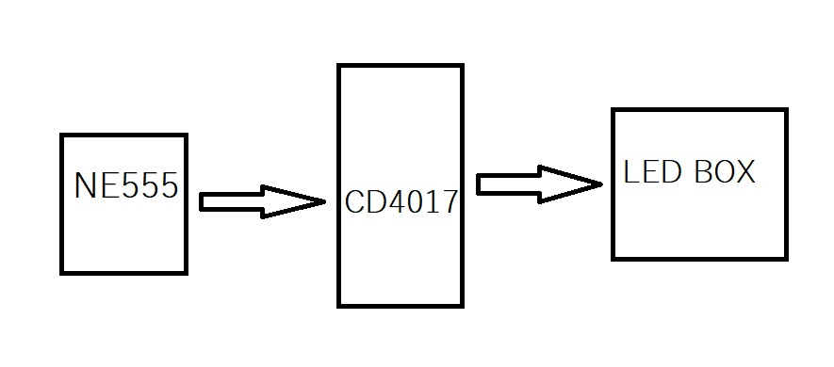

# Circuit Diagram

(*Fully functional circuit diagram with exact connections. Can use Fritzing/Proteus*)

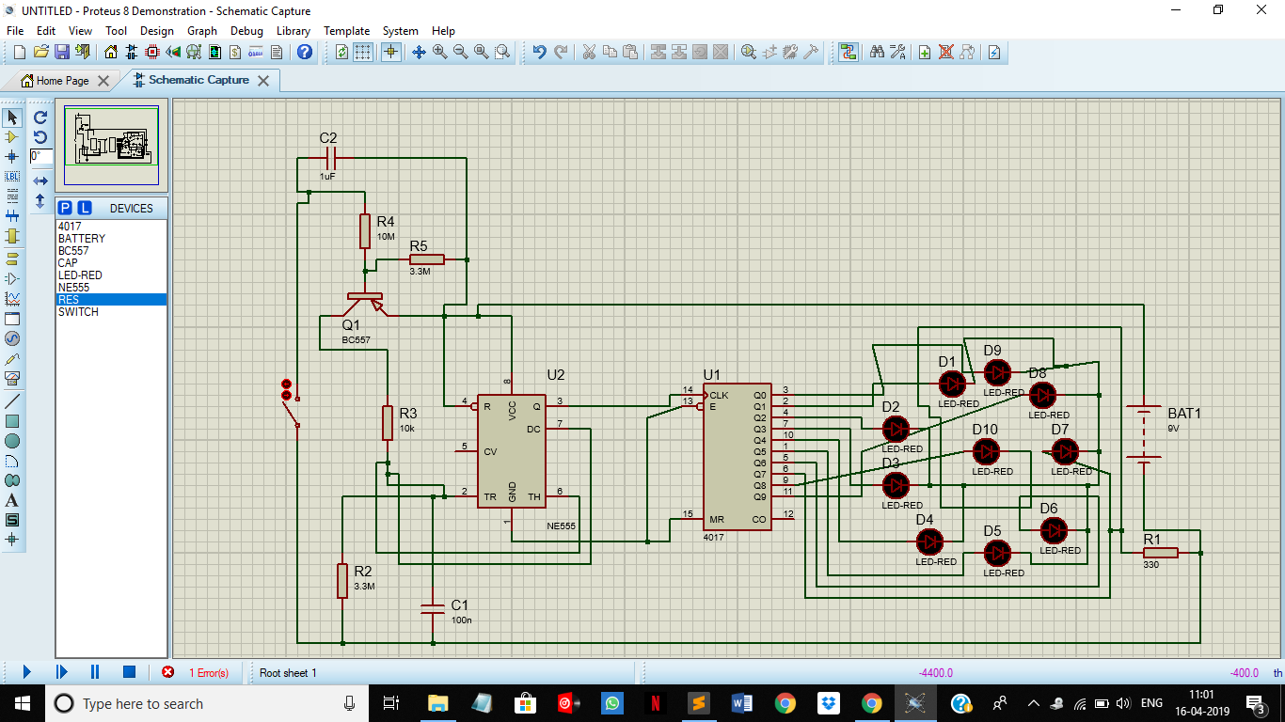

# Materials

(*List down the Components, Equipment, etc. actually used in the project along with the specifications.*)

|  |  |  |
| --- | --- | --- |
| ITEM | QUANTITY | SPECIFICATION |
| NE555 TIMER IC | 1 | It is an integrated circuit (chip) used in variety of timer, pulse generation and oscillator application. |
| CD 4017 DECODED DECADE IC | 1 | A special type of IC in which we need to process the output by using decoder or any other circuitry to make it unable for our application in most of the cases. |
| PNP TRANSITOR BC557 | 1 | Used for current as well as voltage amplification. |
| LED LIGHTS | 10 | For the output. |
| RESISTORS {330R |10K|3.3M|10M } | 4 | To maintain the flow of current. |
| CAPACITORS {1Uf |100n } | 2 | To store electrical energy in form of electrical field. |
| BREADBOARD | 1 | To make connection and circuit on it. |
| LOTS OF BREADBOARD CONNECTORS | 30 | To make connection on breadboard. |
| POWER SUPPLY/ BATTERY (9V) | 1 | For power supply in the circuit |

**4. Outcome**

# Steps of Circuit Completion

(*Bifurcate the circuit completion in steps, specify with photographs, leading to final project*)

**STEP 1: Simulation of NE555**

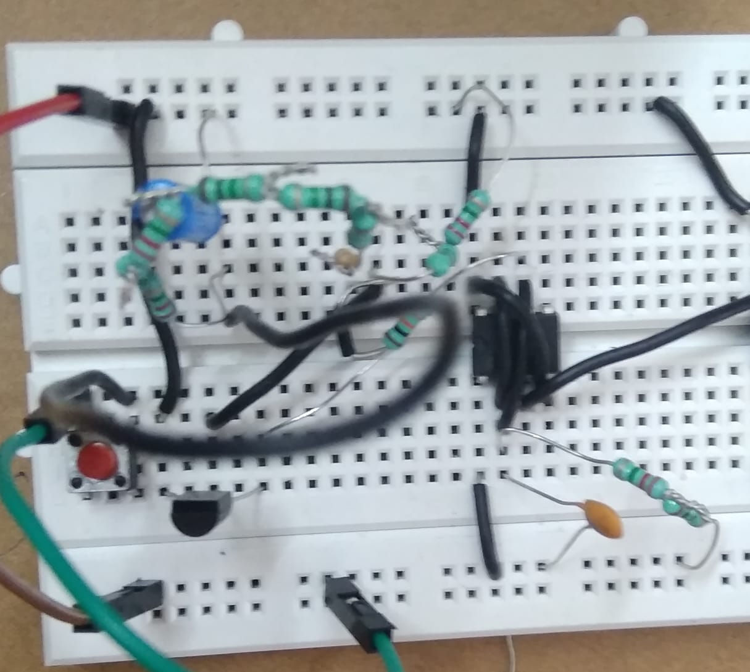

**STEP 2: Simulation of CD4017 IC**

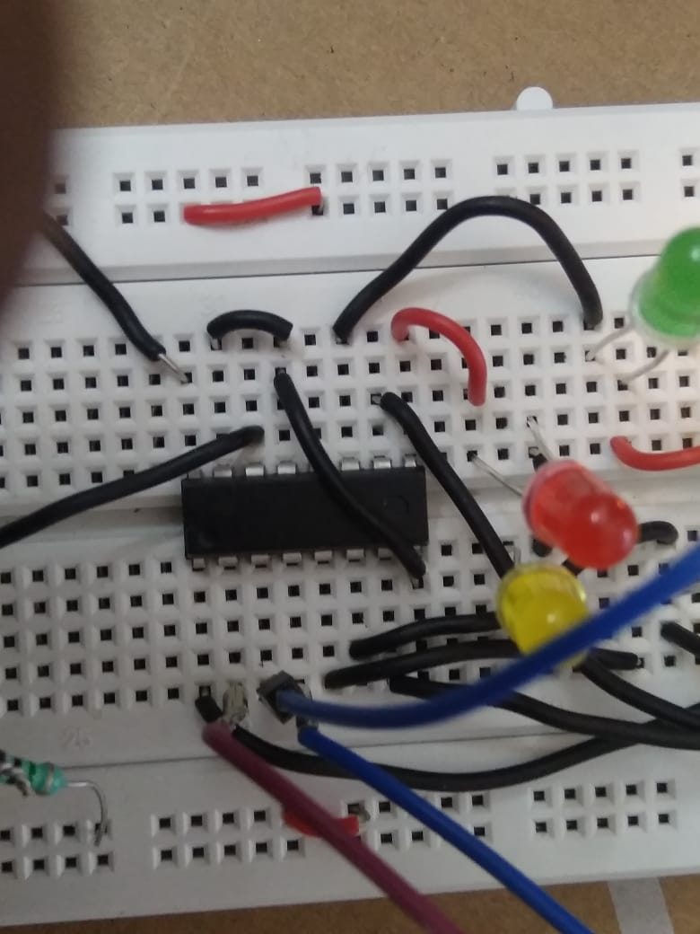

**STEP 3: Setup of LEDs**

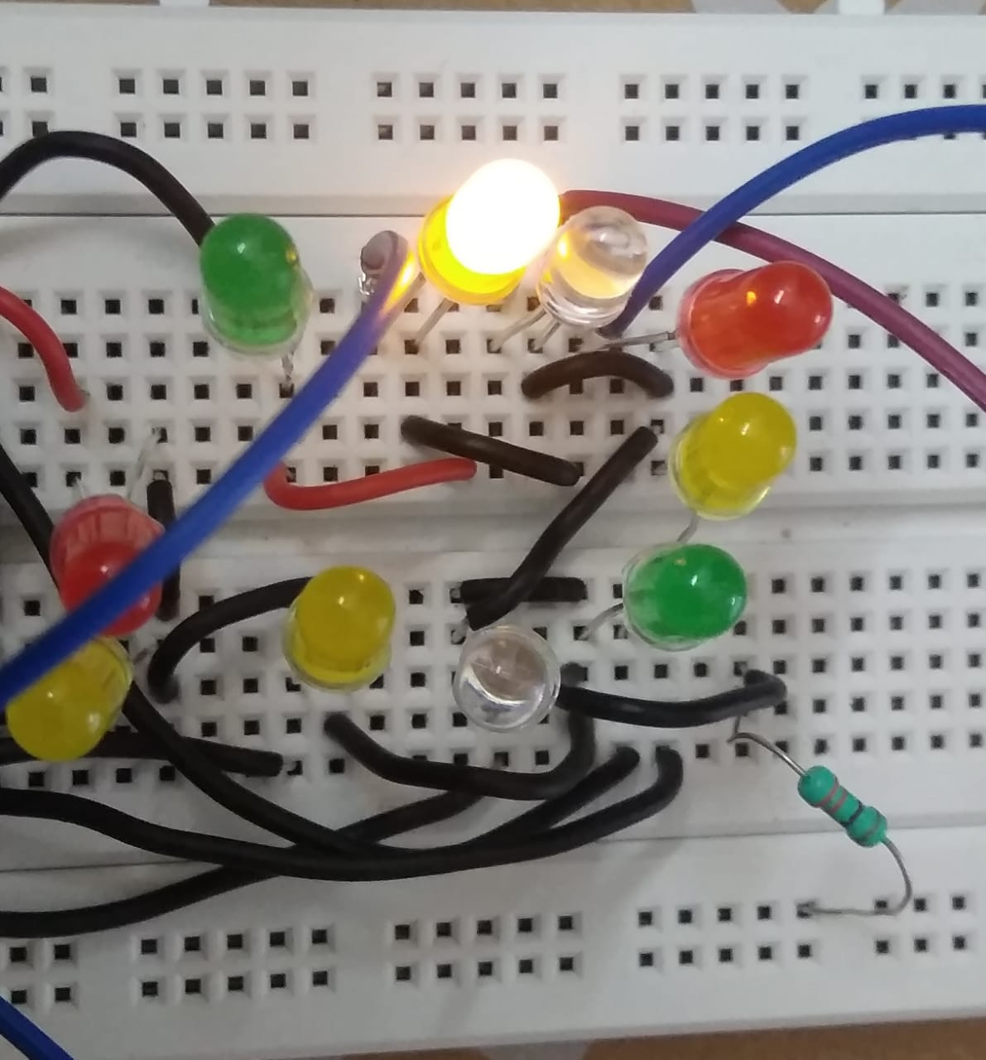

**STEP 4: Complete circuit**

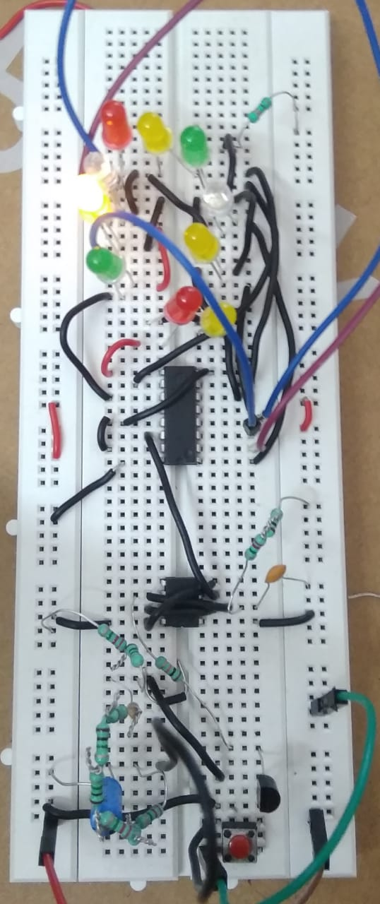

**5. Cost Analysis ( INR= INDIAN REPEE)**

|  |  |  |  |
| --- | --- | --- | --- |
| S.NO | MATERIAL/COMPONENT | QUANTITY | PRICE |
| 1 | NE 555 TIMER IC | 1 | 15 INR |
| 2 | CD 4017 IC | 1 | 15 INR |
| 3 | PNP TRANSISTOR | 1 | 5 INR |
| 4 | LED LIGHTS | 10 | 10 INR |
| 5 | RESISTORS(330R|10K|3.3M|10M) | 4 | 5 INR |
| 6 | CAPACITORS(1Uf|100n) | 2 | 5 INR |
| 7 | BREADBOARD | 1 | 100 INR |
| 8 | LOTS OF BREAD BOARD CONEECTIONS | 30 | 30 INR |
| 9 | POWER SUPPLY/BATTERY(9V) | 1 | 20 INR |
| TOTAL | ---------------------------------------------- | -------------------🡪 | 205 INR |